**Mid-Term Assignment**

**Name:** Apurva Apurva

**Student Id:** 2030407

**Sololearn:**

Screenshots:

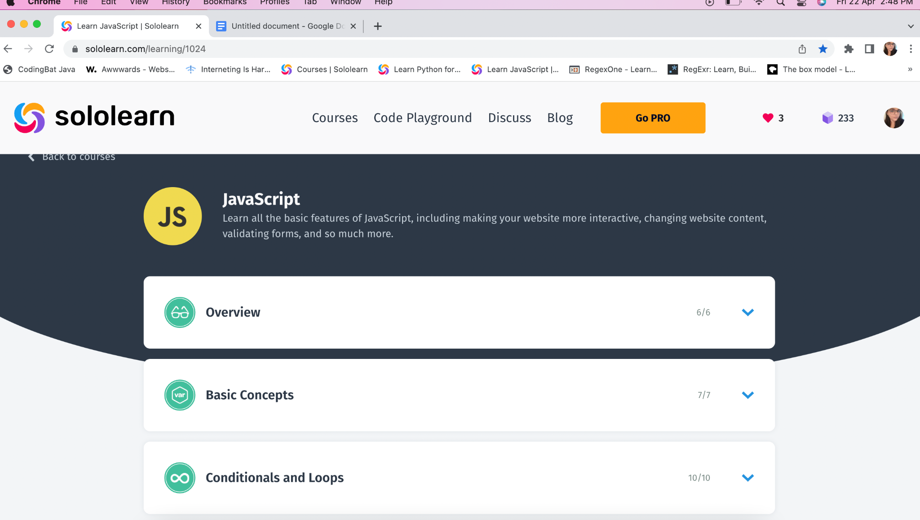

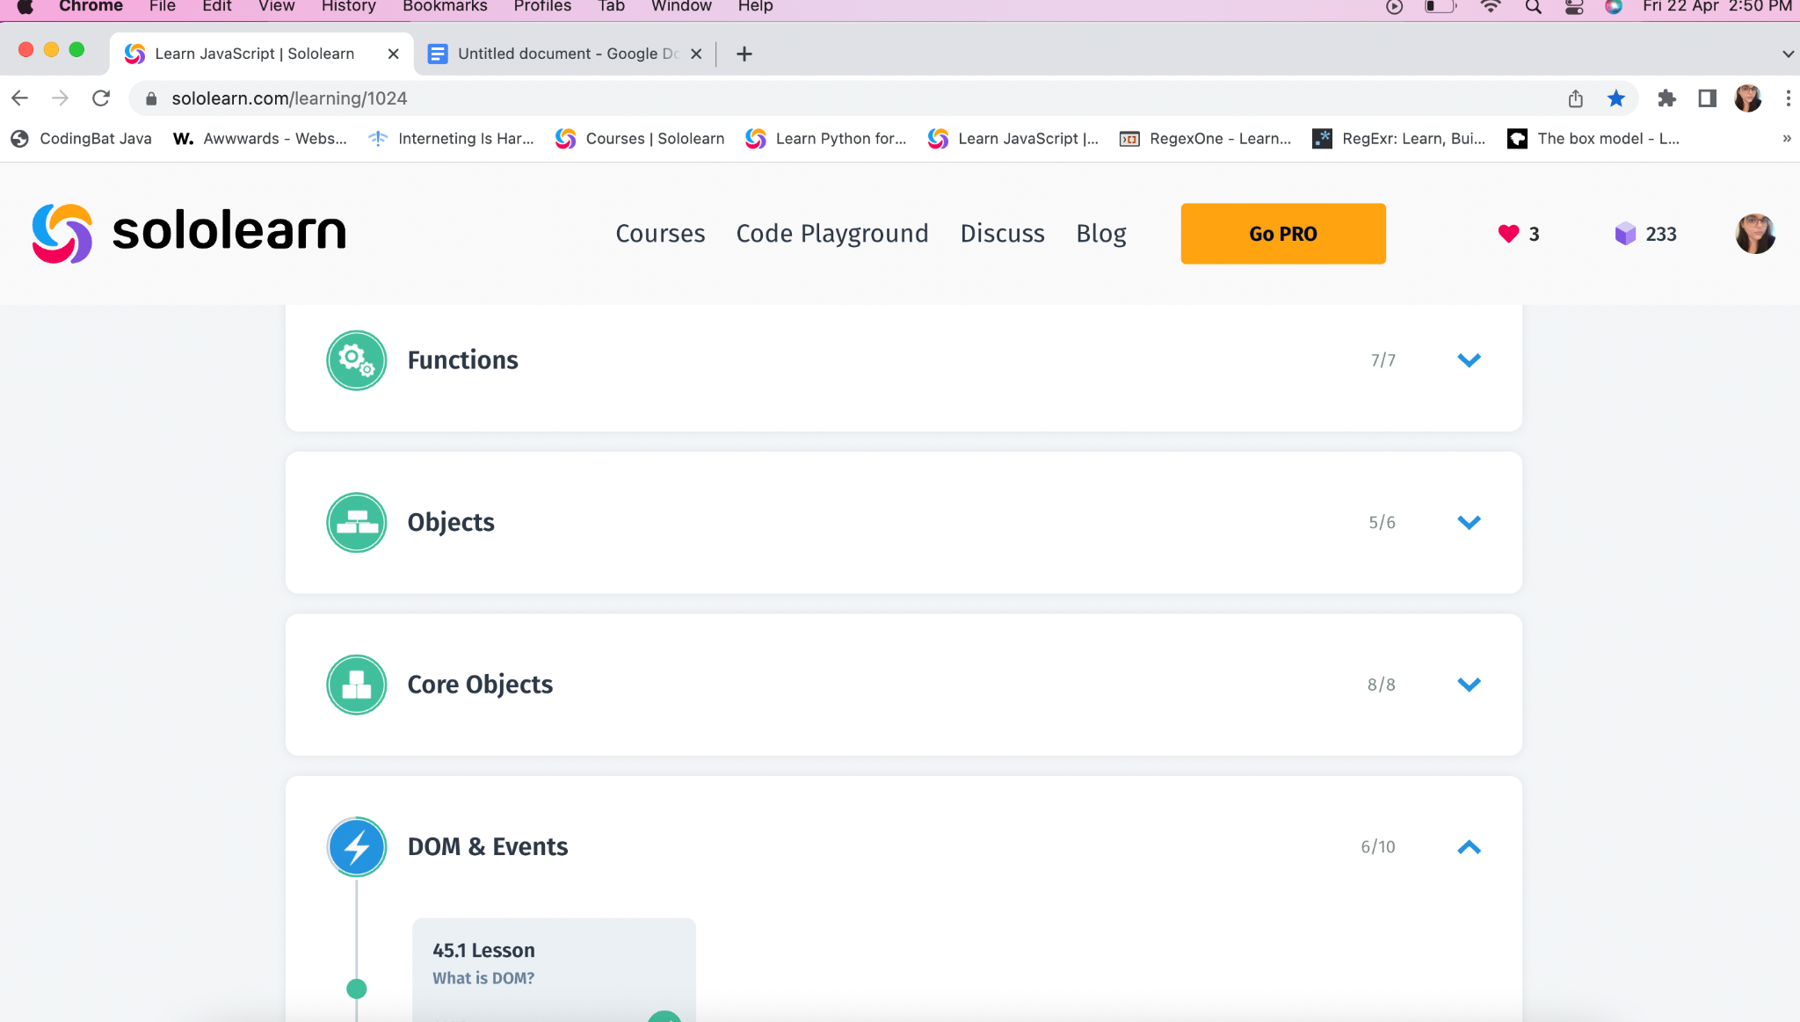

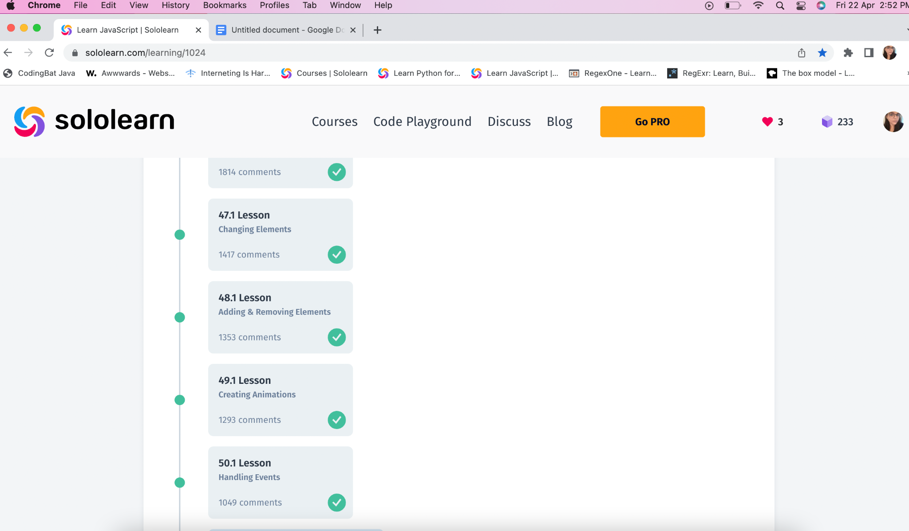

With Sololearn, I learned these topics of JavaScript:

**Overview**: It includes the overview of JavaScript as:

* **Variables**: Containers for storing data values. ​​- The first character of a variable name **must be** a letter, underscore (_), or a dollar sign ($)

- The first character of a variable name **can’t** be a number.

- Variable names **can’t** include a **mathematical or logical operator** in their name.

- Variable names **can’t contain spaces**.

- Special symbols are not allowed, like my#num, num%, etc.

* **Comments**: These are ignored and not executed.

// for single line comment.

/* */ for multiple line comment.

* **Data Types:** The types of values, a program can work with like numbers, strings, arrays, booleans, etc.

**Basic Concepts:** It includes the basic concepts of JavaScript as:

* Math Operators: Arithmetic Operators, such as **+, -, *, /, %, ++, –.**
* Assignment Operators: To assign values to variables, and a few of them are: **=, +=, -=, *=, /=, %=.**
* Comparison Operators: Used to find out if the variables or values are different. The output is either **true** or **false**. **==, ===, !=, !==, >, >=, <, <=.**
* Logical and Boolean Operators: Logical operators are &&, ||, !.
* String Operators: + sign is used for concatenation.

**Conditional and Loops:** It includes the conditional statements such as:

* *The if statement:* This is used to specify the block of code which is executed if a specified **condition is true**.
* *The else statement:* This is used to specify the block of code which is executed if a specified **condition is false**.
* *The else if statement:* This condition is used to specify a new condition **if the first condition is false**.
* *The switch statement:* This is used to perform different actions based on the different conditions.
* *The for loop*: for(statement1; statement2; statement3), where, statement1 is optional and it sets a variable before the loop starts.

Statement2 defines the condition of the loop to be run.

Statement3 increases a value each time a code block in the loop is executed.

* *The while loop:* It repeats through the block of code, as long the condition is true.
* *The do-while loop:* The loop will execute the code block once, before checking if the condition is true, then it will repeat the loop as long as the condition is true.
* *Break and continue statement:* The break is used to jump out of the loop and continue executing the code after the loop, while, the continue statement breaks only one iteration and continues with the next iteration.

**Functions:** It is used to avoid code multiplications and it enables us to use a single code as many times as needed. It includes:

* Function parameters: functionName(param1, param2, param3){ //code}. Multiple parameters can be used with commas in between them as:

functionName(x, y){//code }.

* The return statement: It is used to return the value from the function.
* Alert function: It takes a single parameter, which is the text displayed in the pop-up box.
* Prompt function: It takes two parameters, first the label and second the text to be displayed.
* Confirm function: it comes with “OK” and “Cancel”, if the user clicks, Ok, it returns true, and if the user clicks Cancel, it returns false.

**Objects:** These are the containers of named values. There are object properties, which are used to describe an object, and object methods, for eg, document.write().

**Core Objects:**

* Array: It is an object which stores multiple values in a single variable. It can be accessed by index number within square brackets. The array has a length property and concat() method.
* Math Object: It allows to perform several math tasks, and has different properties like, Math.E, Math.PI.
* Date Object: It enables us to work with dates. JavaScript counts months from 0 to 11, January as 0 and December as 11.

**DOM:** It stands for Document Object Model. JavaScript can be used to manipulate the DOM of a page dynamically to add, delete and modify elements.

It consists of DOM tree.

We can select elements by documents.getElementById, documents.getElementByClassName, documents.getElementByTagName.

**Git Repository link:** https://github.com/Persistent-A/WebApplicationDevelopment.git